**NAME: ADEBOYE TOLULOPE MARY**

**E-MAIL:** [**adeboyetolulope0@gmail.com**](mailto:adeboyetolulope0@gmail.com)

**SQL PRACTICE ASSIGNMENT**

1. **Display the customer names that share the same address (e.g. Husband and Wife)**

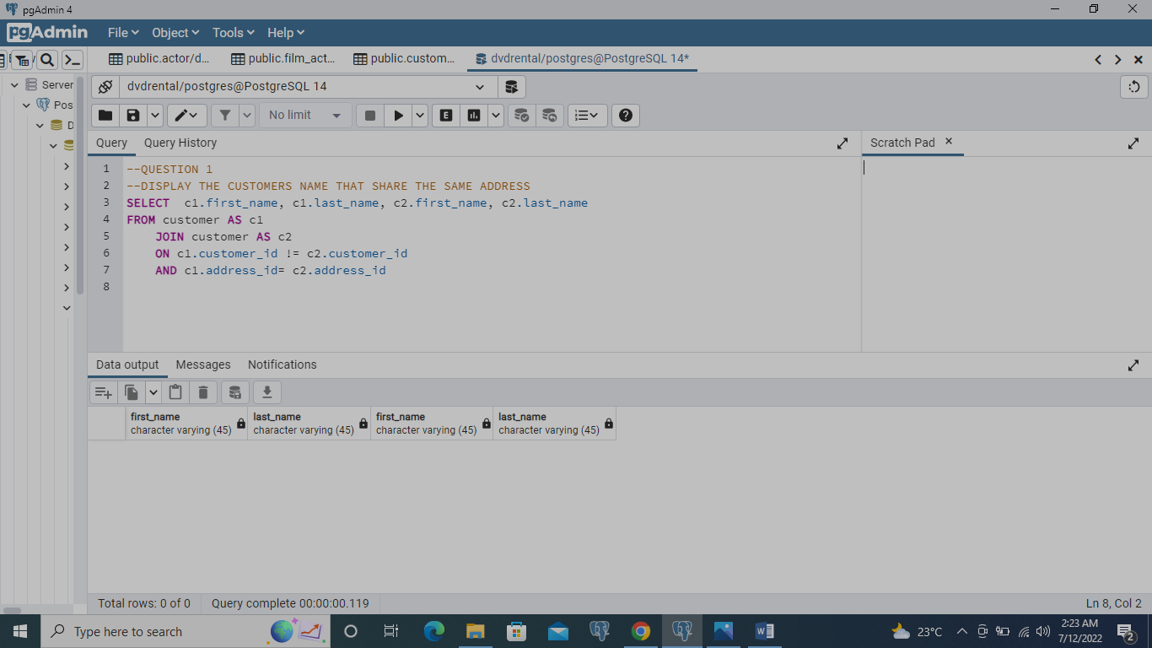

**SELECT c1.first_name, c1.last_name, c2.first_name, c2.last_name**

**FROM customer AS c1**

**JOIN customer AS c2**

**ON c1.customer_id != c2.customer_id**

**AND c1.address_id= c2.address_id**

1. **What is the name of the customer who made the highest total payments**

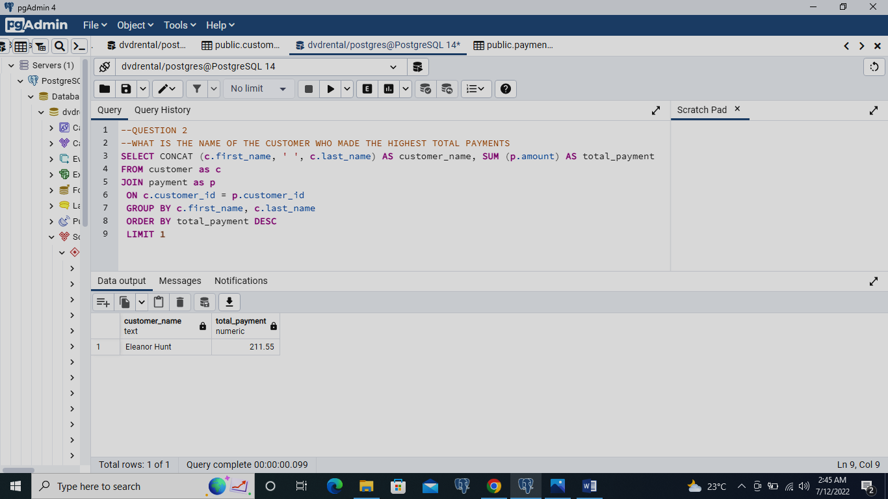

**SELECT CONCAT (c.first_name, ' ', c.last_name) AS customer_name, SUM (p.amount) AS total_payment**

**FROM customer as c**

**JOIN payment as p**

**ON c.customer_id = p.customer_id**

**GROUP BY c.first_name, c.last_name**

**ORDER BY total_payment DESC**

**LIMIT 1**

1. **What is the movie(s) that was rented the most?**

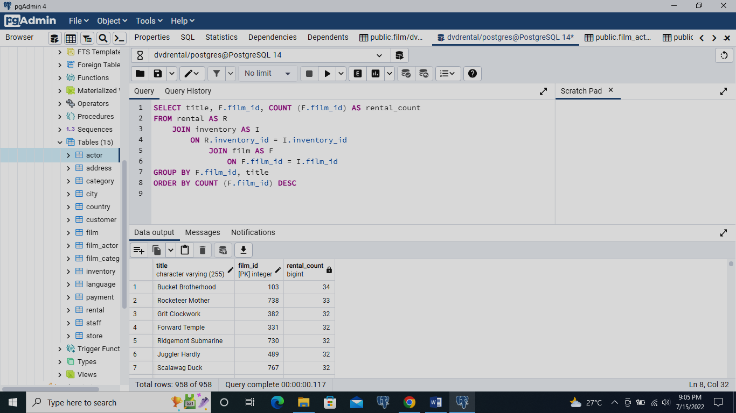

**SELECT title, F.film_id, COUNT (F.film_id) AS rental_count**

**FROM rental AS R**

**JOIN inventory AS I**

**ON R.inventory_id = I.inventory_id**

**JOIN film AS F**

**ON F.film_id = I.film_id**

**GROUP BY F.film_id, title**

**ORDER BY COUNT (F.film_id) DESC**

1. **Which movies has been rented so far?**

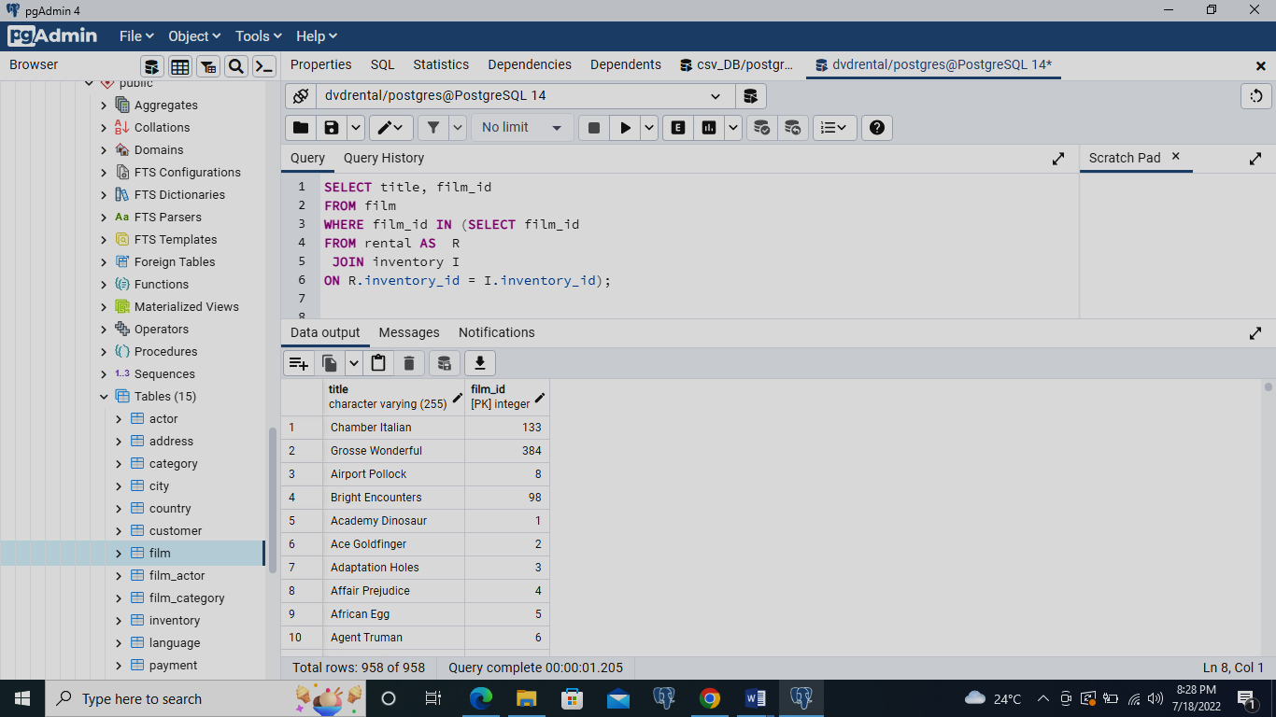

**SELECT title, film_id**

**FROM film**

**WHERE film_id IN (SELECT film_id**

**FROM rental AS R**

**JOIN inventory I**

**ON R.inventory_id = I.inventory_id);**

1. **Which movies have not been rented so far**

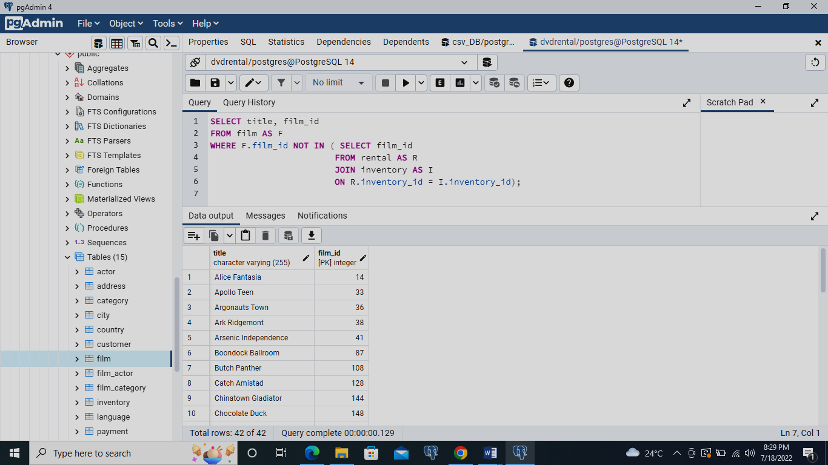

**SELECT title, film_id**

**FROM film AS F**

**WHERE F.film_id NOT IN ( SELECT film_id**

**FROM rental AS R**

**JOIN inventory AS I**

**ON R.inventory_id = I.inventory_id);**

1. **Which customers have not rented any movie so far?**

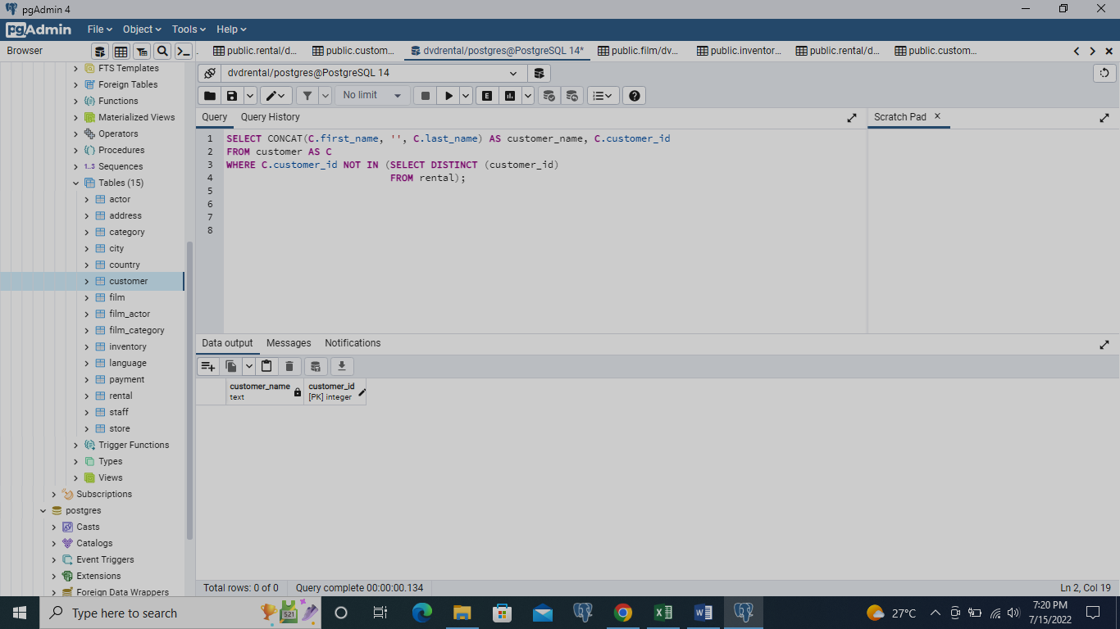

**SELECT CONCAT(C.first_name, '', C.last_name) AS customer_name, C.customer_id**

**FROM customer AS C**

**WHERE C.customer_id NOT IN (SELECT DISTINCT (customer_id)**

**FROM rental);**

1. **Display each movie and the number of times it got rented?**

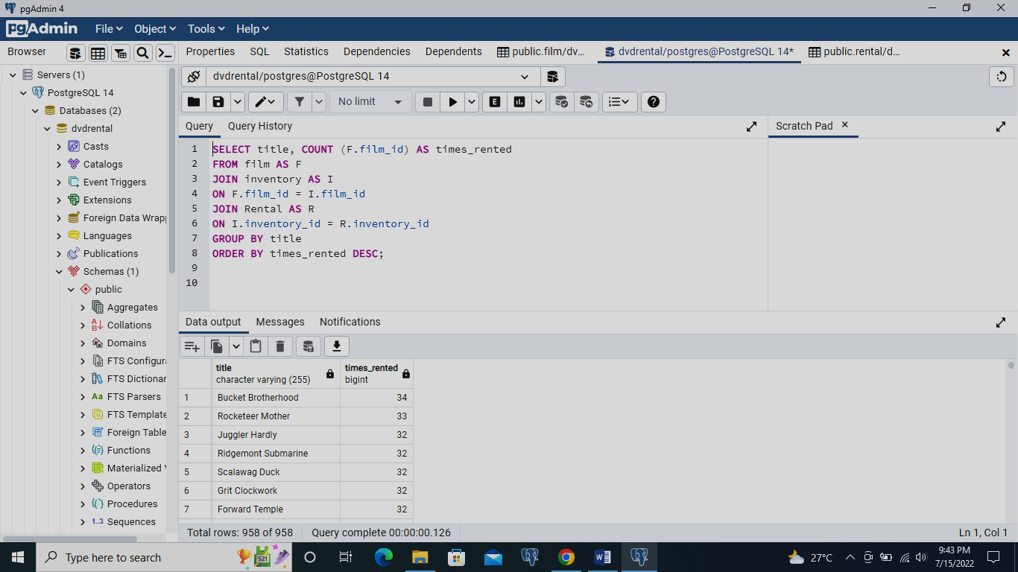

**SELECT title, COUNT (F.film_id) AS times_rented**

**FROM film AS F**

**JOIN inventory AS I**

**ON F.film_id = I.film_id**

**JOIN Rental AS R**

**ON I.inventory_id = R.inventory_id**

**GROUP BY title**

**ORDER BY times_rented DESC;**

1. **Show the first name and last name and the number of films each actor acted in**

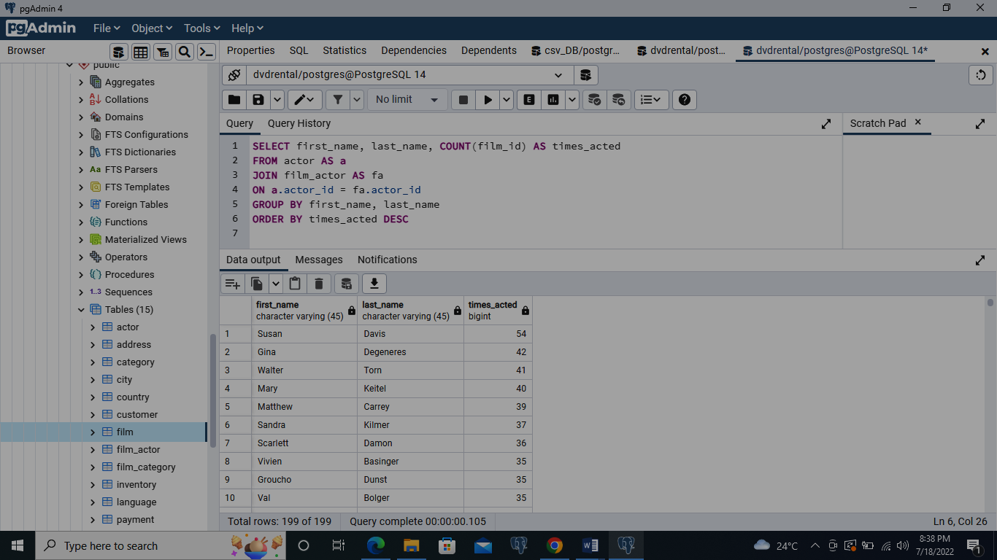

**SELECT first_name, last_name, COUNT(film_id) AS times_acted**

**FROM actor AS a**

**JOIN film_actor AS fa**

**ON a.actor_id = fa.actor_id**

**GROUP BY first_name, last_name**

**ORDER BY times_acted DESC**

1. **Display the names of the actor that acted in more than 20 movies**

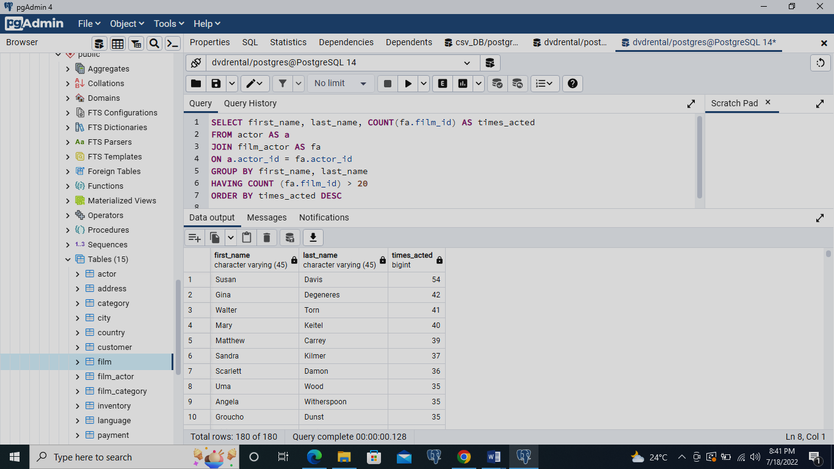

**SELECT first_name, last_name, COUNT(fa.film_id) AS times_acted**

**FROM actor AS a**

**JOIN film_actor AS fa**

**ON a.actor_id = fa.actor_id**

**GROUP BY first_name, last_name**

**HAVING COUNT (fa.film_id) > 20**

**ORDER BY times_acted DESC**

1. **For all movies rated “PG”, show me the movies and the number of time it got rented.**

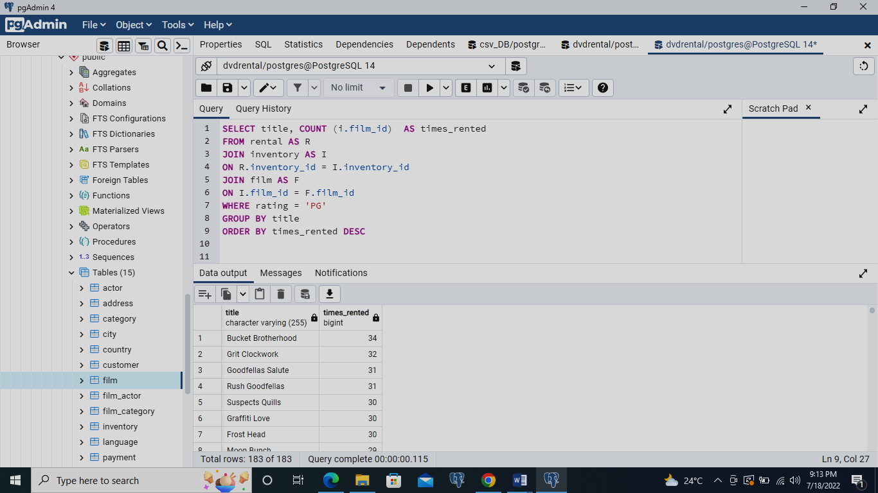

**SELECT title, COUNT (i.film_id) AS times_rented**

**FROM rental AS R**

**JOIN inventory AS I**

**ON R.inventory_id = I.inventory_id**

**JOIN film AS F**

**ON I.film_id = F.film_id**

**WHERE rating = 'PG'**

**GROUP BY title**

**ORDER BY times_rented DESC**

1. **Display the movies offered for rent in store_id1 and not offered in store_id2**

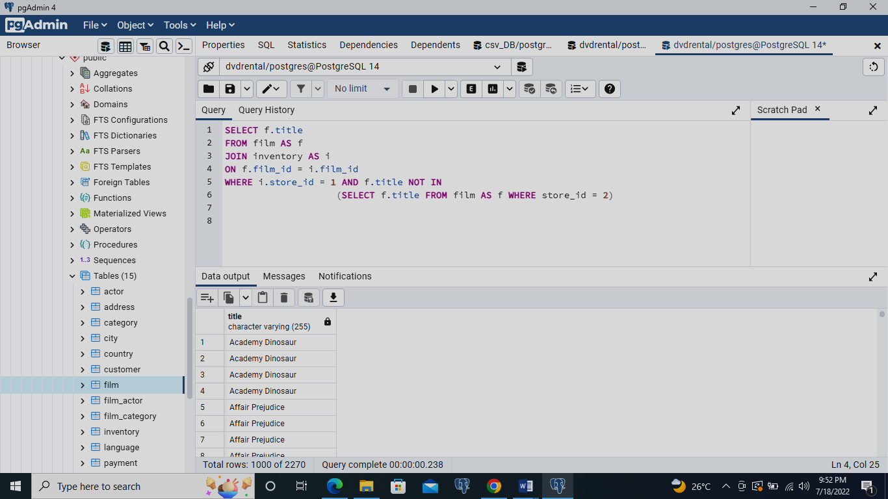

**SELECT f.title**

**FROM film AS f**

**JOIN inventory AS i**

**ON f.film_id = i.film_id**

**WHERE i.store_id = 1 AND f.title NOT IN**

**(SELECT f.title FROM film AS f WHERE store_id = 2)**

1. **Display the movie offered for rent in any of the two stores 1 and 2**

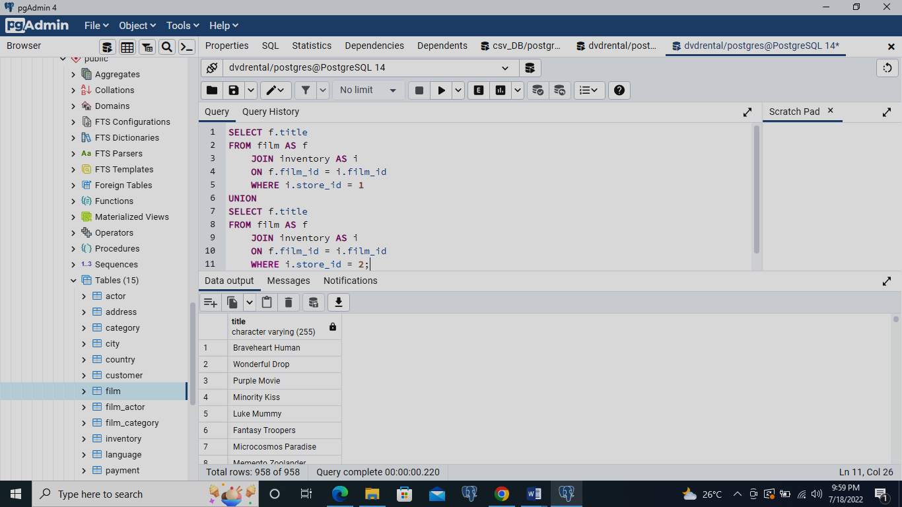

**SELECT f.title**

**FROM film AS f**

**JOIN inventory AS i**

**ON f.film_id = i.film_id**

**WHERE i.store_id = 1**

**UNION**

**SELECT f.title**

**FROM film AS f**

**JOIN inventory AS i**

**ON f.film_id = i.film_id**

**WHERE i.store_id = 2;**

1. **Display the movie titles of those movies offered in both stores at the same time**

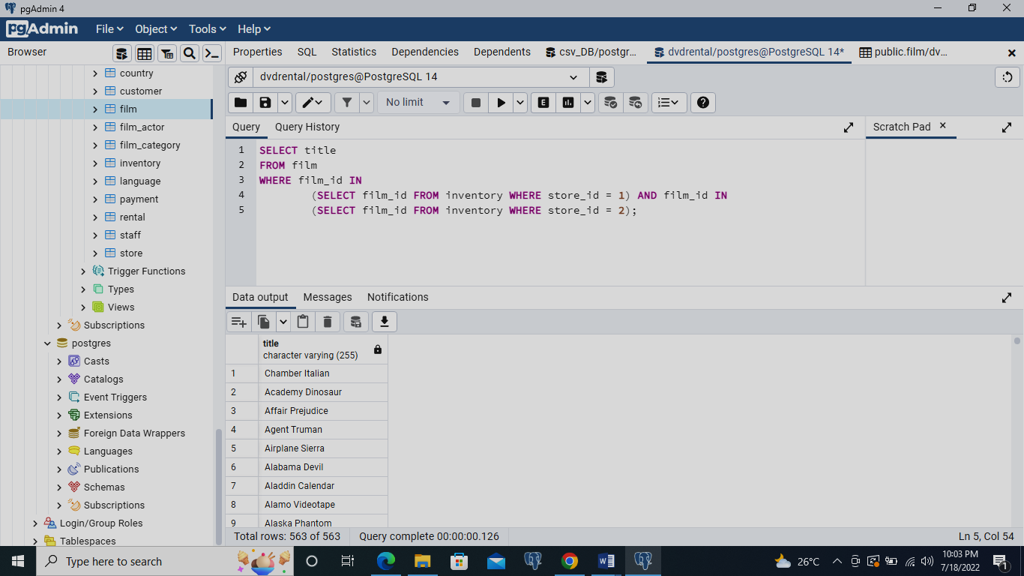

**SELECT title**

**FROM film**

**WHERE film_id IN**

**(SELECT film_id FROM inventory WHERE store_id = 1) AND film_id IN**

**(SELECT film_id FROM inventory WHERE store_id = 2);**

1. **Display the movie title for the most rented movie in the store with store id 1**

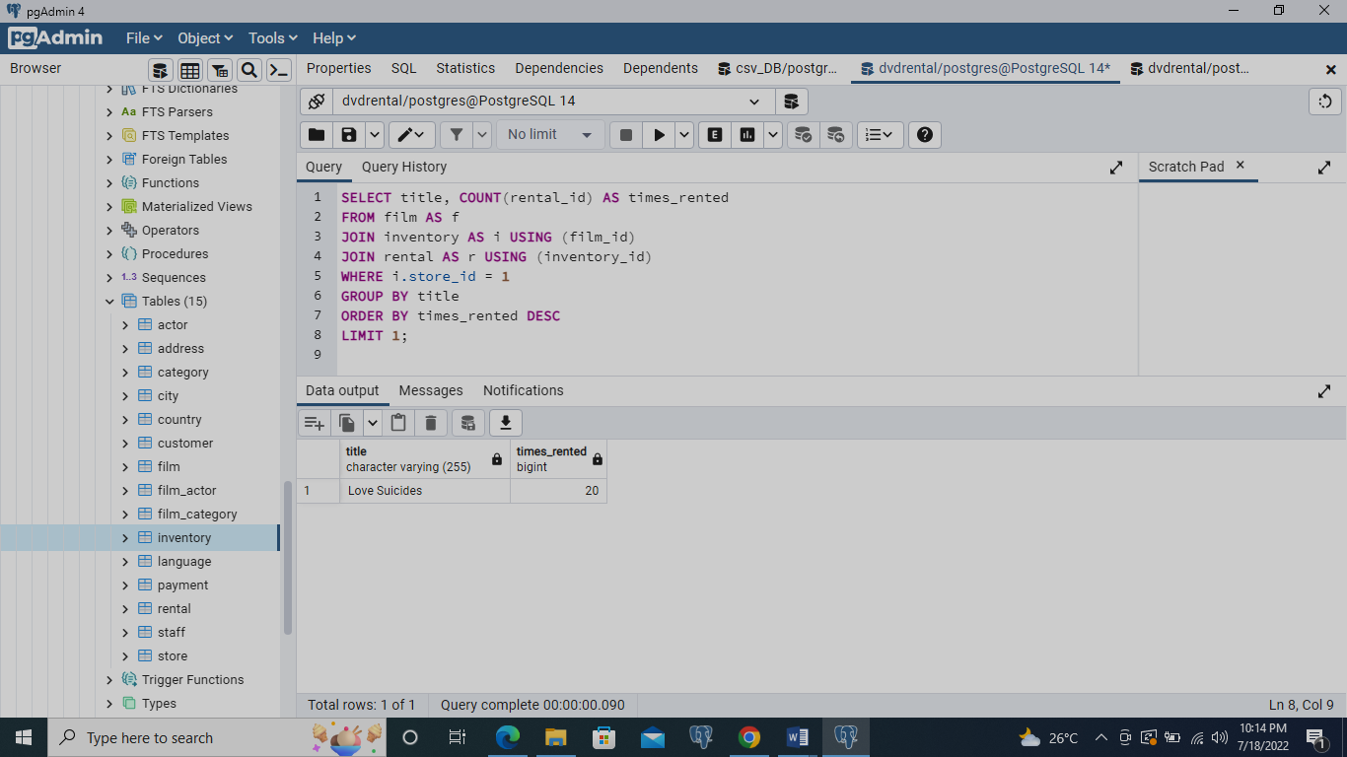

**SELECT title, COUNT(rental_id) AS times_rented**

**FROM film AS f**

**JOIN inventory AS i USING (film_id)**

**JOIN rental AS r USING (inventory_id)**

**WHERE i.store_id = 1**

**GROUP BY title**

**ORDER BY times_rented DESC**

**LIMIT 1;**

1. **How many movies are not offered for rent in the stores yet, there are two stores 1 and 2.**

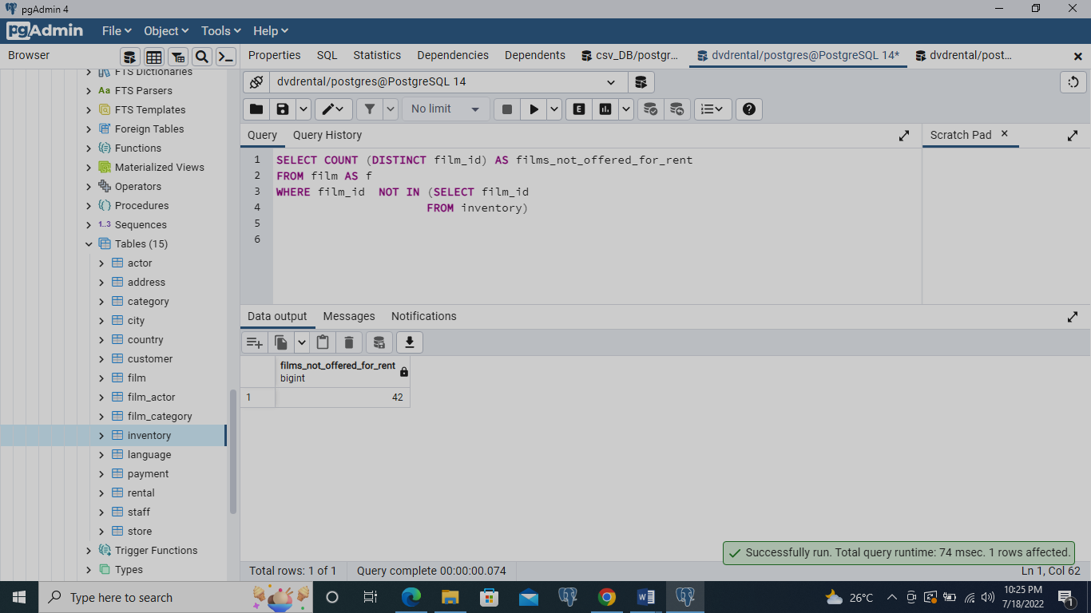

**SELECT COUNT (DISTINCT film_id) AS films_not_offered_for_rent**

**FROM film AS f**

**WHERE film_id NOT IN (SELECT film_id**

**FROM inventory)**

1. **Show the number of rented movies under each rating.**

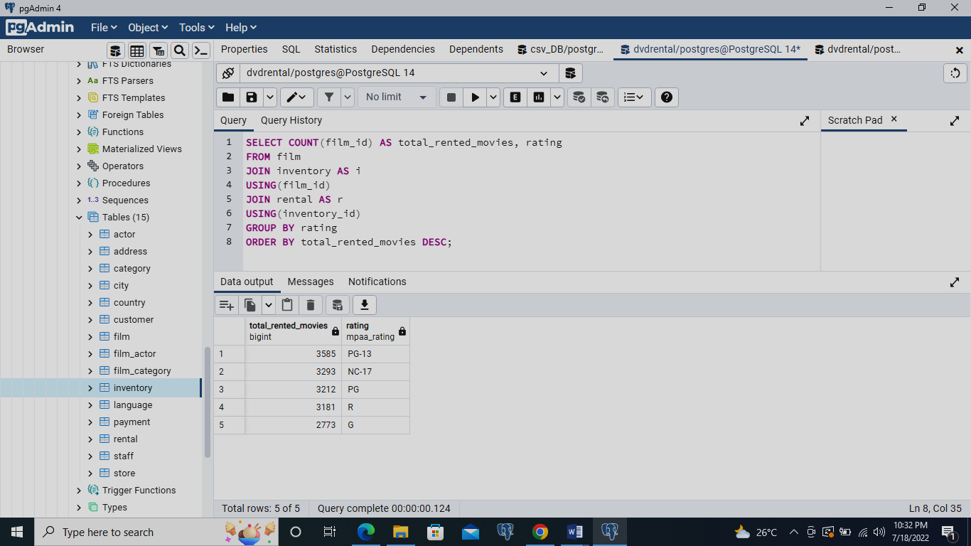

**SELECT COUNT(film_id) AS total_rented_movies, rating**

**FROM film**

**JOIN inventory AS i**

**USING(film_id)**

**JOIN rental AS r**

**USING(inventory_id)**

**GROUP BY rating**

**ORDER BY total_rented_movies DESC;**

1. **Show the profit of each of the stores 1 and 2**

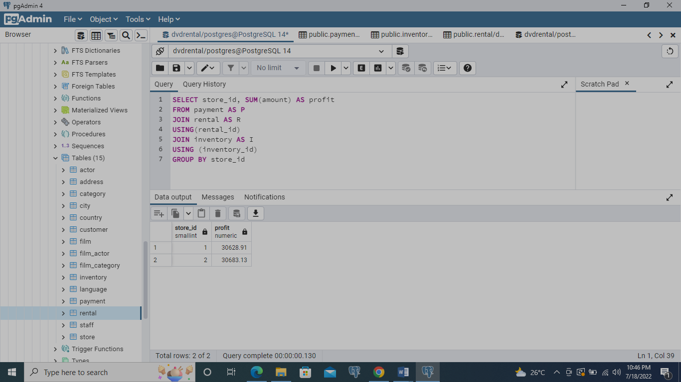

**SELECT store_id, SUM(amount) AS profit**

**FROM payment AS P**

**JOIN rental AS R**

**USING(rental_id)**

**JOIN inventory AS I**

**USING (inventory_id)**

**GROUP BY store_id**